**Software Construction & Development**

Course Instructor

**Dr Affan Rauf**

Submitted By

**20F-0281 Laiba Idrees**

Section

**BSE-5A**

 Date

**Sunday, October 3, 2021**

Fall 2021



**Department of Computer Science**

FAST – National University of Computer & Emerging Sciences

Chiniot-Faisalabad Campus

# Use case

|  |  |
| --- | --- |
| 1. Use case name | **View Help** |
| Primary Actor | User |
| Precondition | The user must have access to the database. |
| Post condition | Till the user closes the Help page. |
| Main success scenario | 1-Navigate towards the help icon panel.  2-The user can go forward from page 1 to TBD.  3-The user can also go to previous pages. |
| Alternative flow | For Further help users can reach the team through an email, which will be provided at the bottom of the home page. |

|  |  |
| --- | --- |
| Use case name | **Login Admin** |
| Primary Actor | Admin |
| Precondition | The system must be in working state and online on the provided network. |
| Post condition | The clearance status of ADMIN for the portal will be displayed, and the home page will be opened. |
| Main success scenario | 1-Select the log-in panel.  2-Enter correct sequence of admin id.  3-Enter correct sequence of admin password.  4-prompt log-in panel. |
| Alternative flow | No Alternative flow. |

|  |  |
| --- | --- |
| Use case name | **Edit History** |
| Primary Actor | User |
| Precondition | The user must have searched up at least one word to form a history. |
| Post condition | 1-The user will be shown a confirmation message upon deletion.  2-The selected words will be removed from the history |
| Main success scenario | 1-Select ‘History’ panel  2-Select the entries you want to remove  3-Confirm deletion |
| Alternative flow | There user may exit the history page without deleting anything |

|  |  |
| --- | --- |
| Use case name | **Give feedback** |
| Primary Actor | User |
| Precondition | The user must be in the feedback panel. |
| Post condition | Confirmation message will be shown upon submission. |
| Main success scenario | 1-The user can write text in the given block.  2- The user will click submit. |
| Alternative flow | No Alternative flow. |

|  |  |
| --- | --- |
| Use case name | **Edit favorite** |
| Primary Actor | User |
| Precondition | The word must exist in the database |
| Post condition | The page must be added in the saved edit panel. |
| Main success scenario | 1-Select ‘Edit favorite’ panel  2-Select the word you want to add.  3-Confirm addition. |
| Alternative flow | No Alternative flow. |

|  |  |
| --- | --- |
| Use case name | **Search word** |
| Primary Actor | User |
| Precondition | The desktop application must be active |
| Post condition | The searched word will be displayed on the page, or the suggestions will be given in case the word isn’t found. |
| Main success scenario | 1-The user will select the search bar.  2-The user will enter the desired word in the search bar.  3-If the word is found, all related info will be displayed, this includes Romanized pronunciation, definition, word root, and translations.  4- A user may directly add the displayed word to add to favorites.  5-If the word is not found, the program will prompt the user with similar words as a suggestion. |
| Alternative flow | If a word does not exist, it will give suggestion of words with similar associations. |

|  |  |
| --- | --- |
| Use case name | **Add word** |
| Primary Actor | Admin |
| Precondition | The admin must be logged in |
| Post condition | The database will be maintained/updated |
| Main success scenario | 1-The admin will select the add word button on admin panel.  2-The user will enter the desired word in the given form.  3-The admin will also add all related info this includes Romanized pronunciation, definition, word root, and translations.  4- The admin will enter the word into the database by clicking the button.  5-A confirmation message will appear. |
| Alternative flow | If a word already exists, the word will not be registered in the data base. |

# SDD

1. **Edit history**

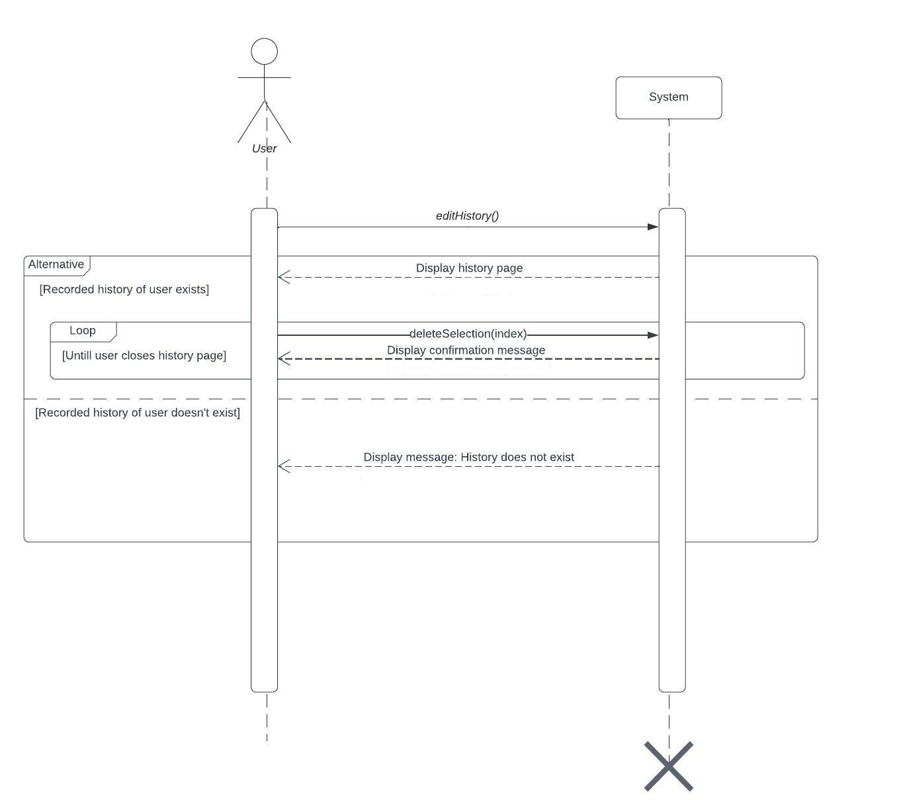

1. **Search word**

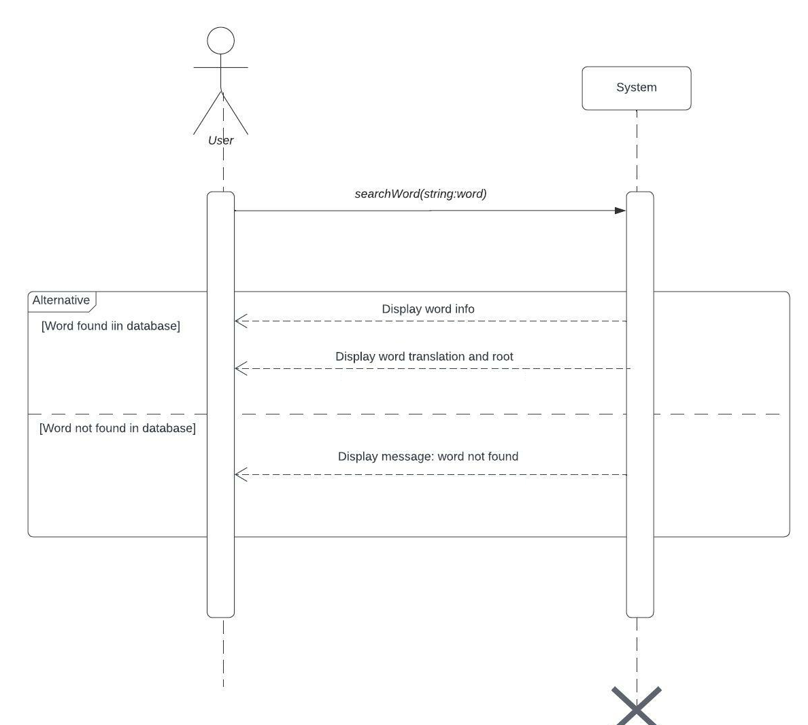

1. **View help**

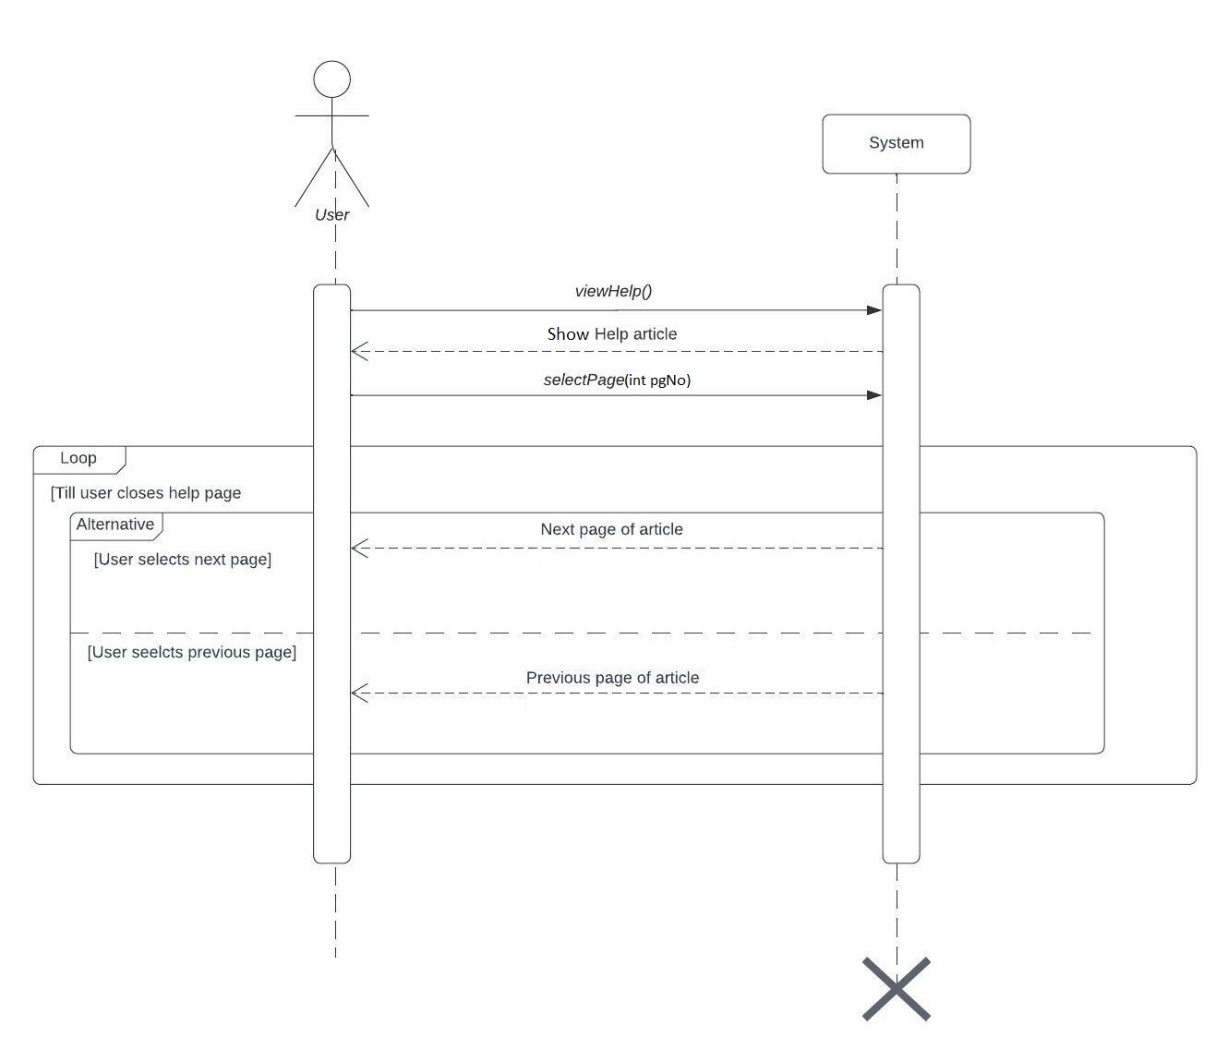

1. **Add favorite**

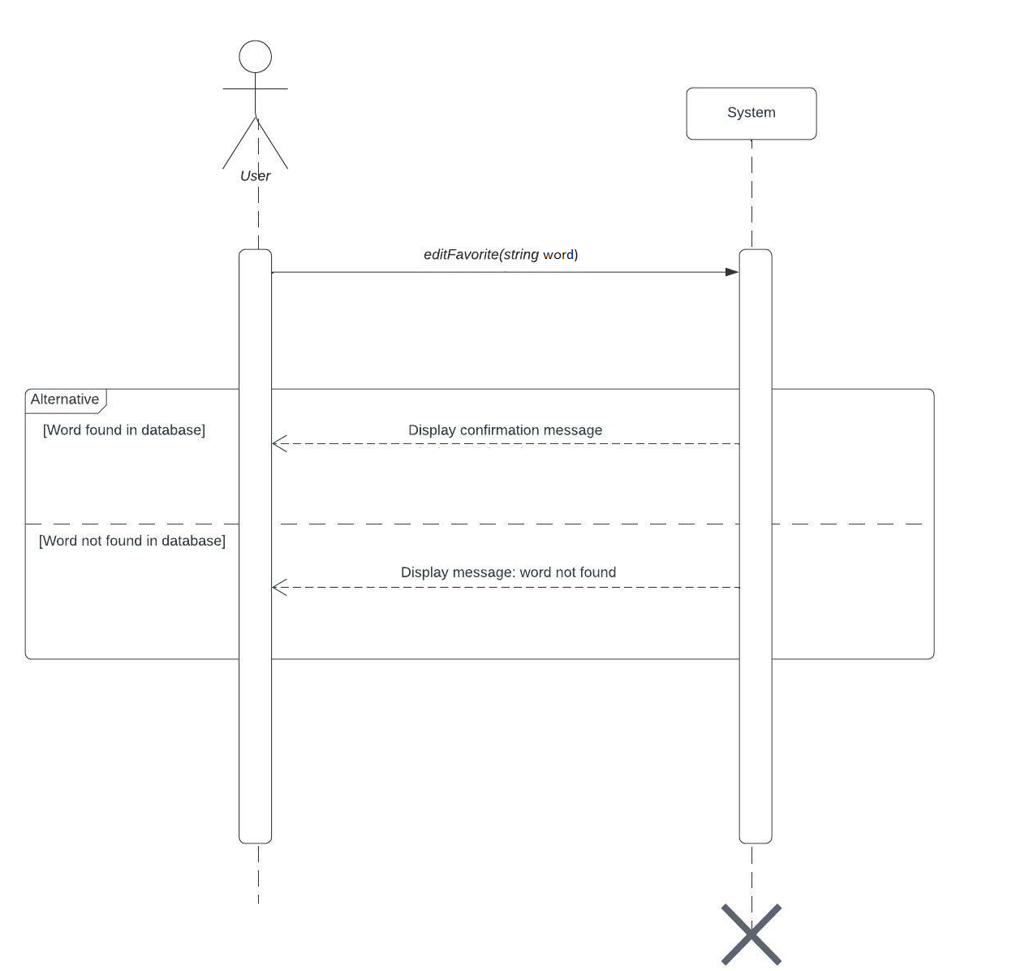

1. **Login admin**

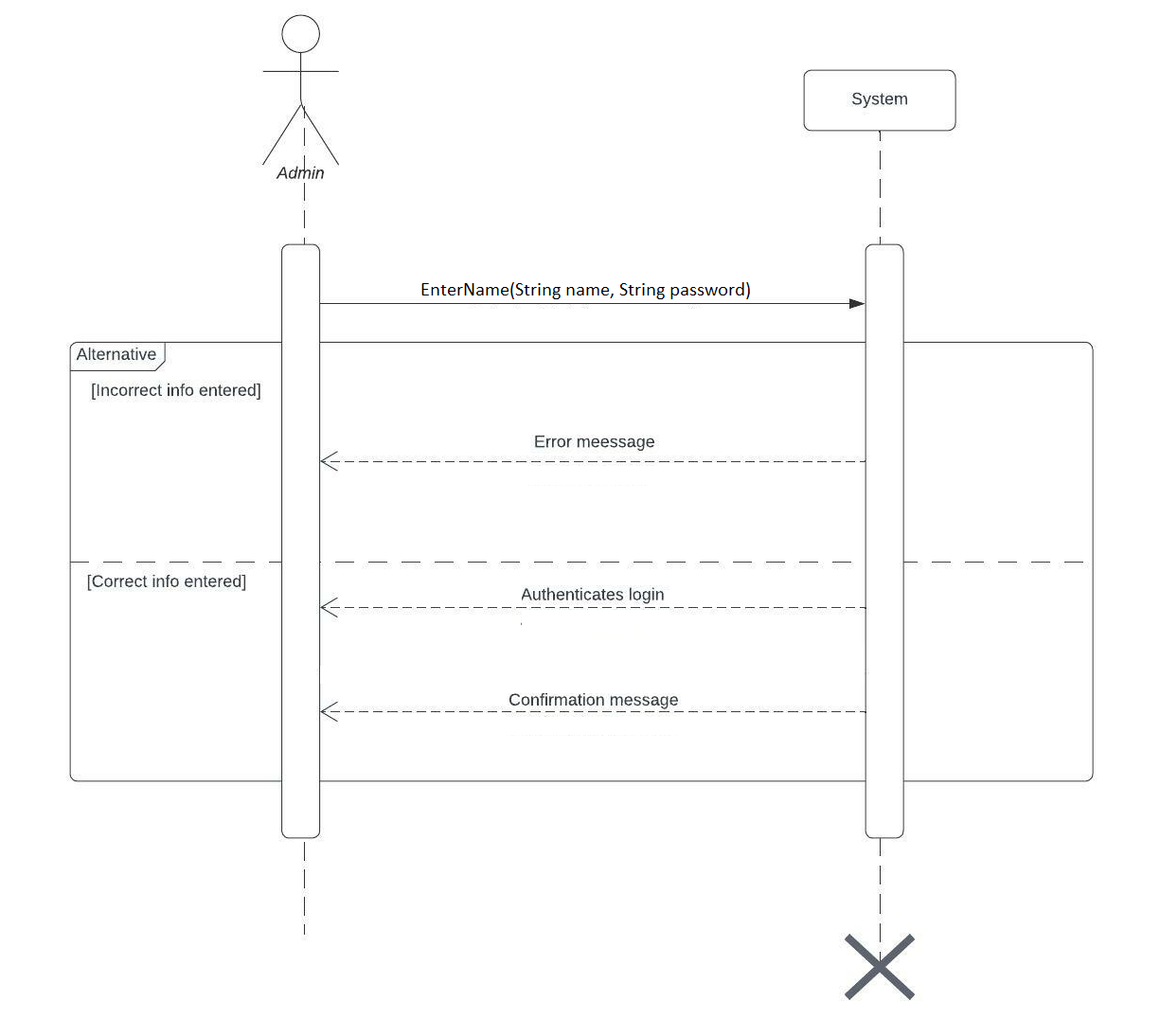

1. **Give feedback**

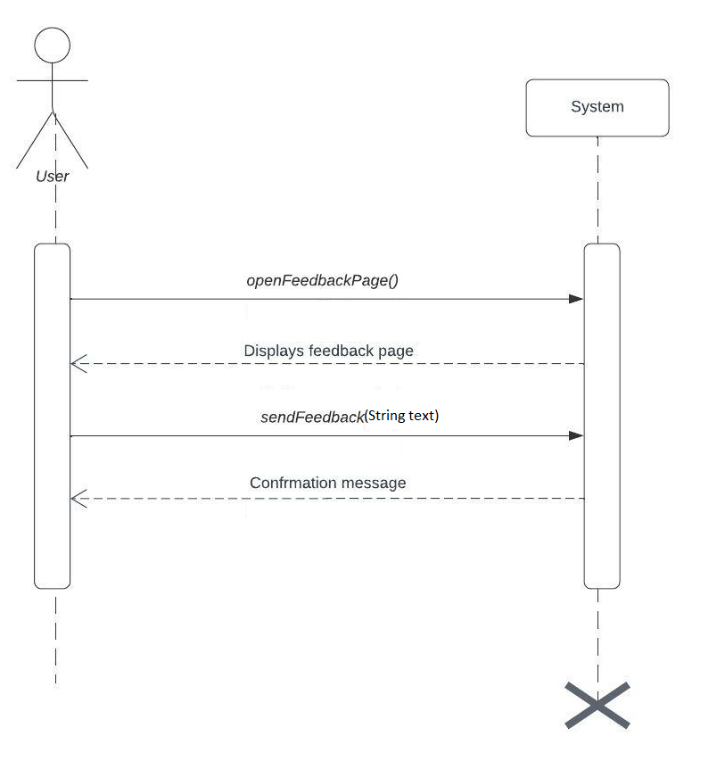

1. **Add word**

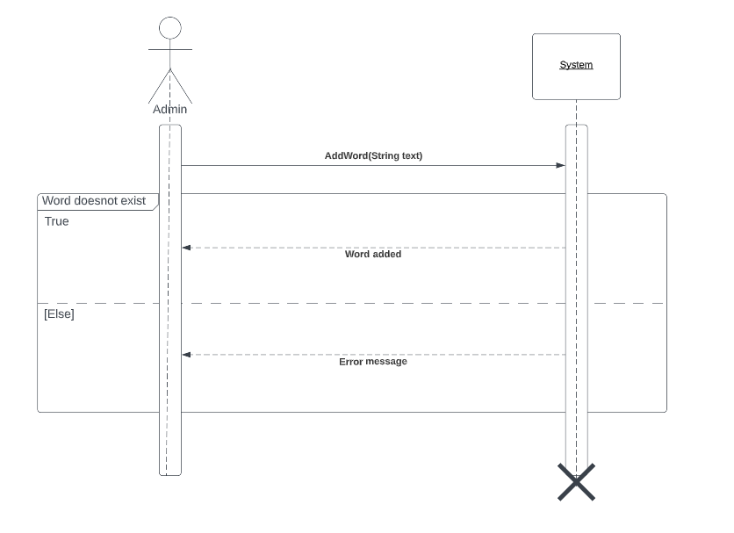

# Domain Model Diagram

